How to access Clever from home

Using Bing or Google search for
“cobb clever”

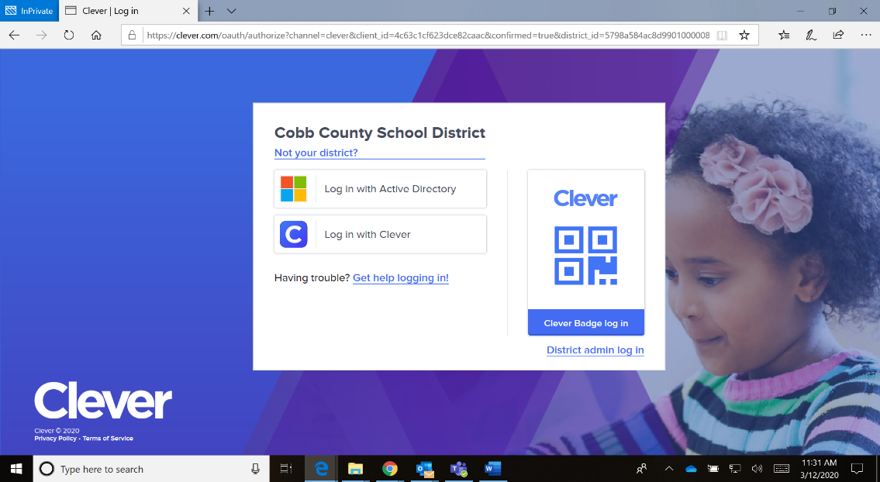

Click on Log in with Active Directory

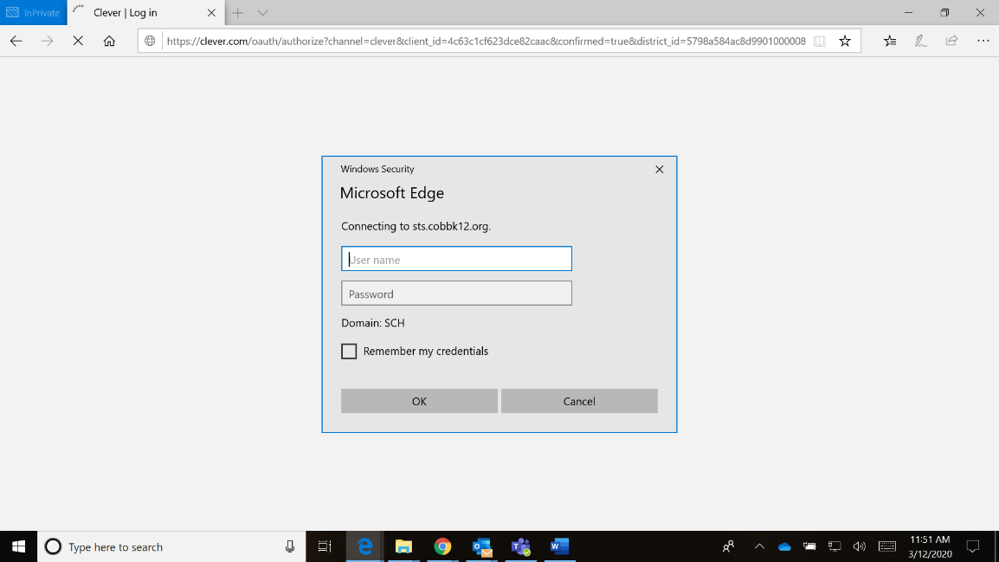
Sign in using
Username: your student ID
(otherwise known as
breakfast number or lunch number or computer number)
Password: computer password
If you are using a mobile device you might need to use
Username: firstname.lastname@students.cobbk12.org
Password: computer password

