LearningExpress Library access

- Go to www.cobbcat.org/librarypass
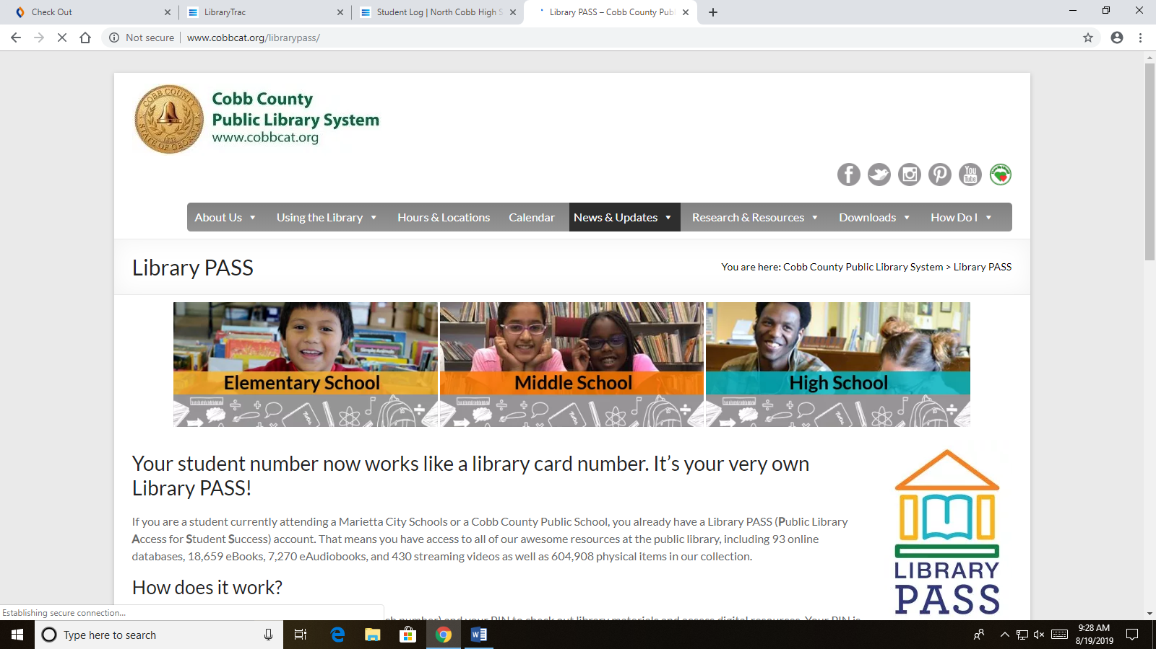

- Select the dropdown menu right of center called “Research & Resources”, then select “Databases & Electronic Resources” to land on this page:
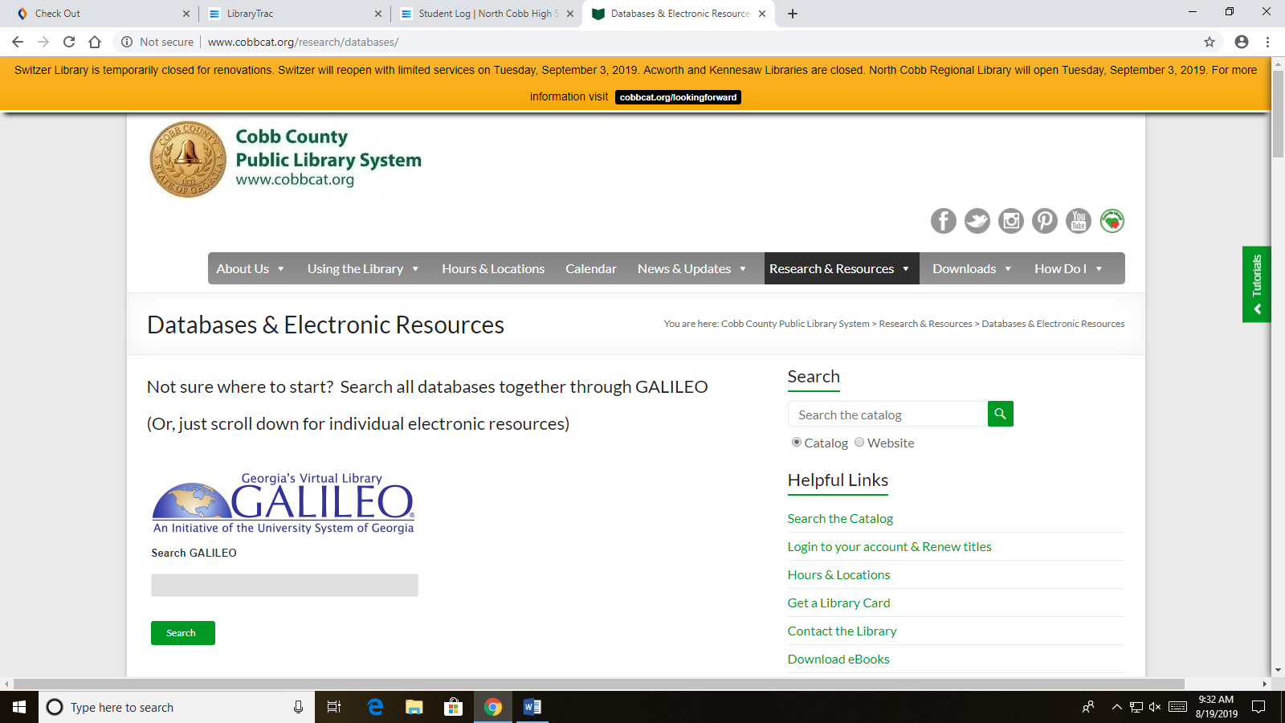
- From here, scroll down to the bottom of the page and look for the last section called “Resource Categories By Subject”. Select the last bullet called “Test Preparation” to go to this new page:
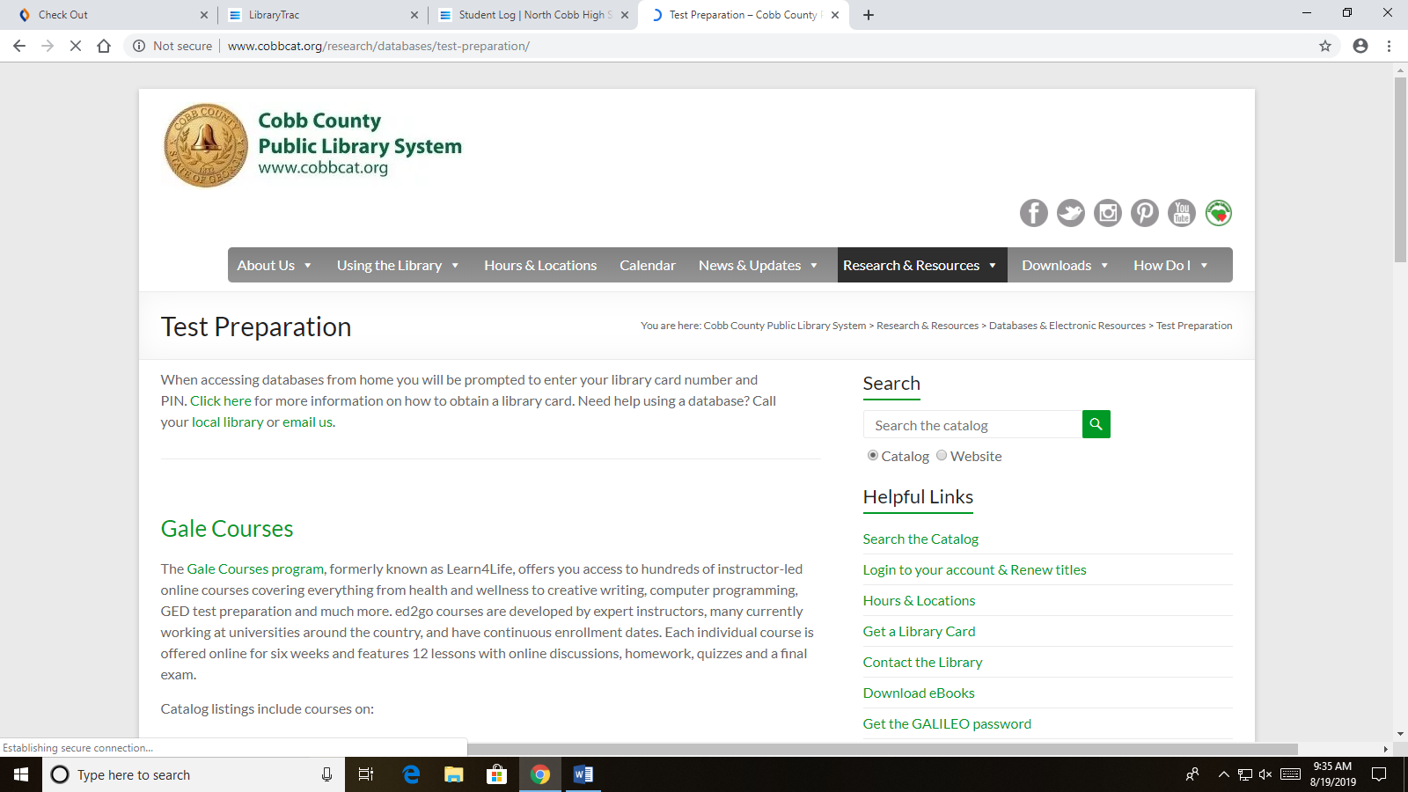

- On this page, scroll down to “LearningExpress Library” and click on this section in order to be prompted to login to the Cobb County Library System:
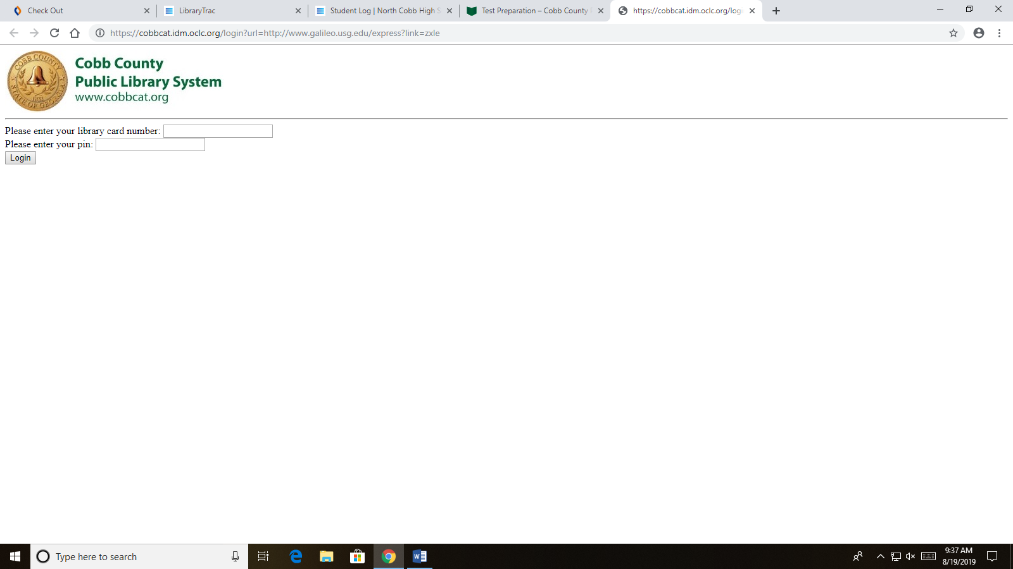
- Your library card number is your student number, and your pin is your 4-digit birthday, month and day (do not enter your year!). For example, if your birthday is March 2nd, you would enter “0302”… enter a zero in front of the number if it is less than 10 for month and day.
If you are successful, you will land here:
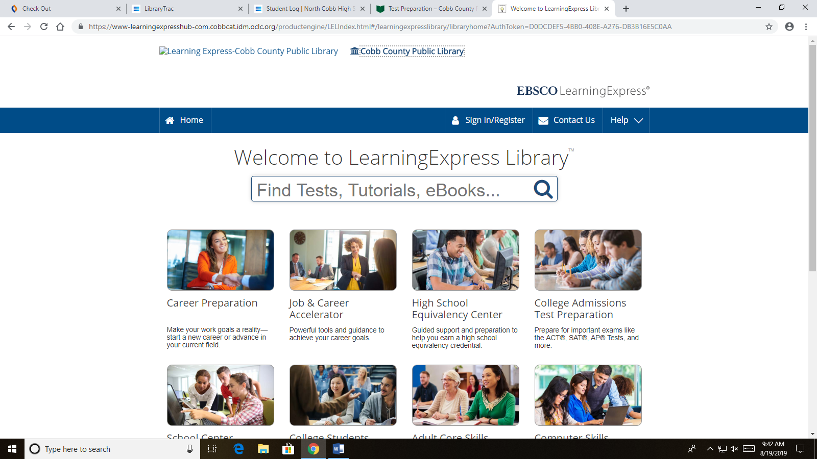

- At this point, click on “Sign In/Register at the top right of the top blue ribbon, which will bring you here:
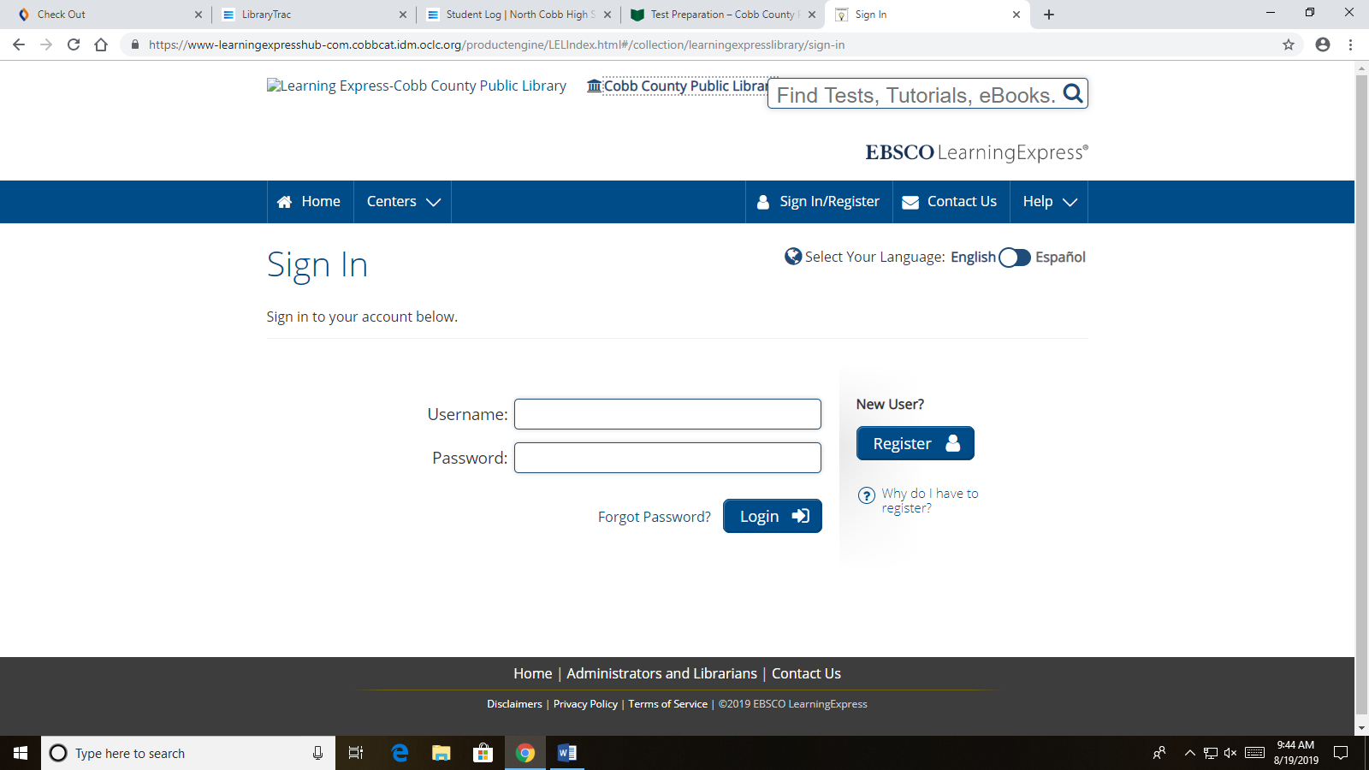
- Now click on “Register” if you have not registered for an account before. If you have, simply sign in with the credentials you created. To register, follow the instructions on the screen and click “Register” when you complete the required fields:
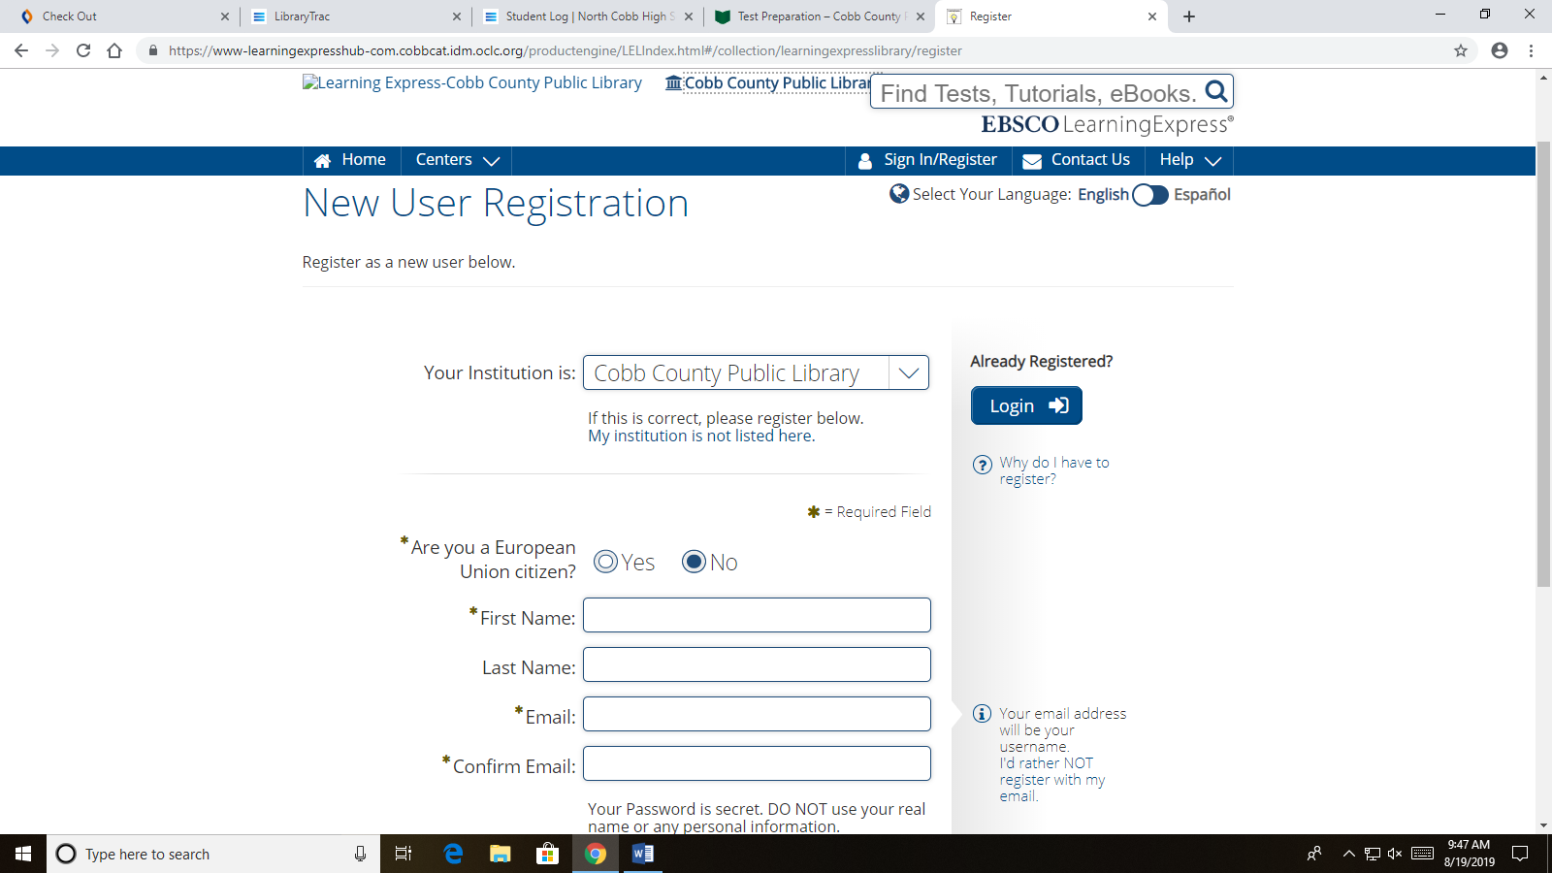

- Once you create an account, click on the Home button at the top left at which point you will come back to this screen, from which you can select “College Admission Test Preparation” at the far right of the screen. Choose the option(s) that are appropriate for your needs:
